**Abhinav Jain**

**500083840**

**Development Automation and Linux**

**Experiment-1**

**Introduction to Shell Scripting**

* **Basic ‘echo’ and ‘read’ functions:-**

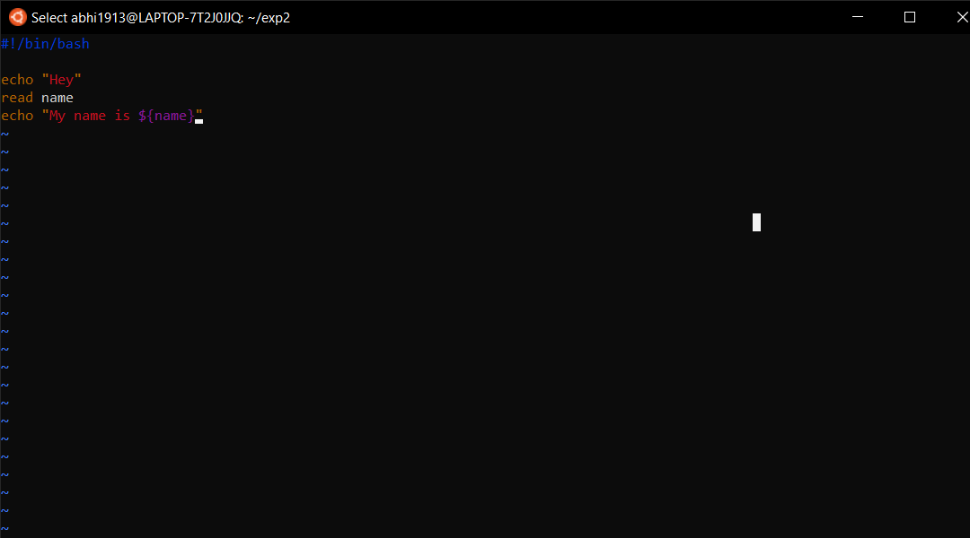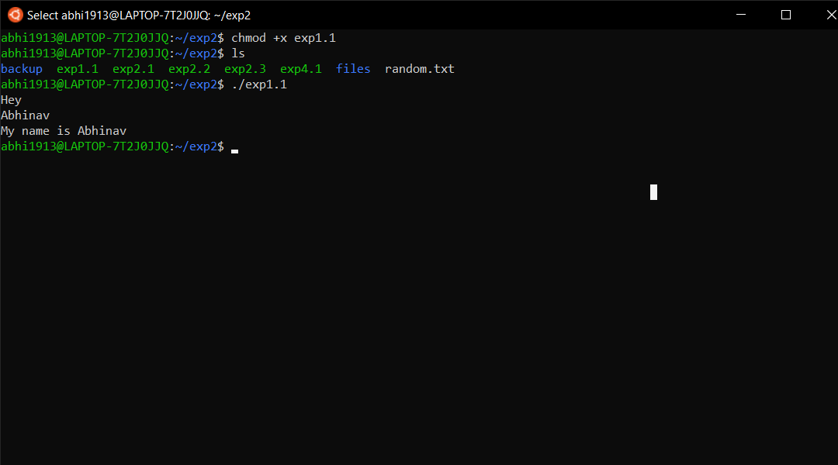

* **Shell script for basic arithmetic task:-**

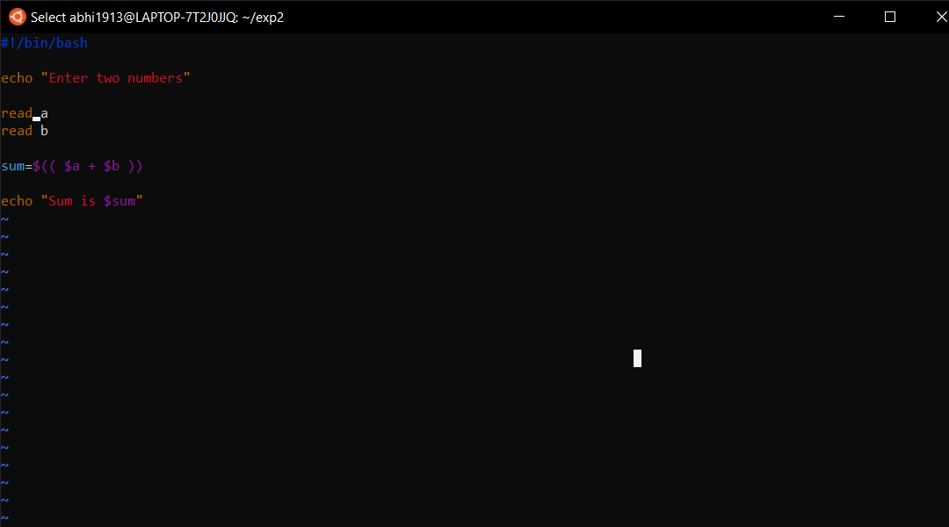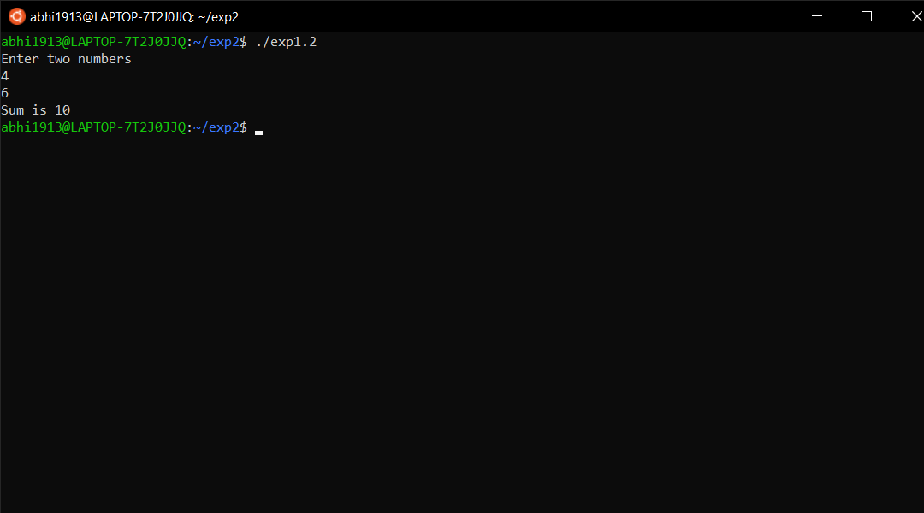

* **Conditional Statements:-**

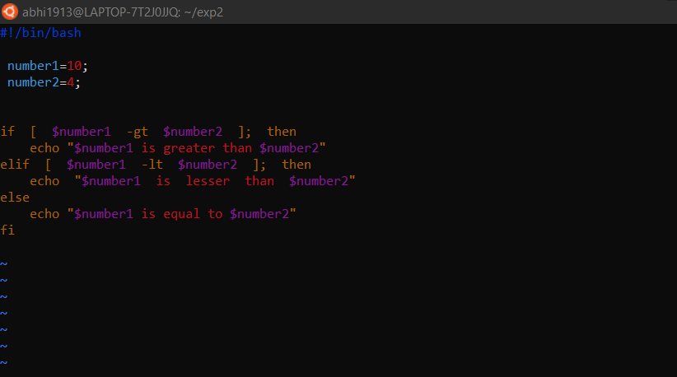

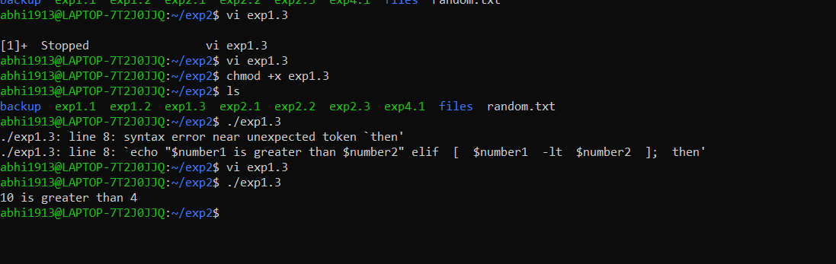

* **Loops:-**

1. **For Loop:-**

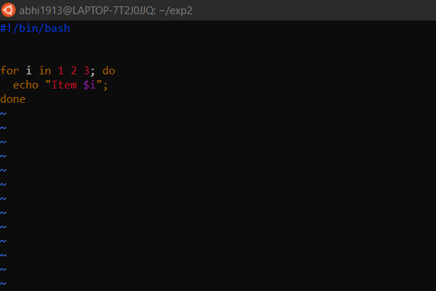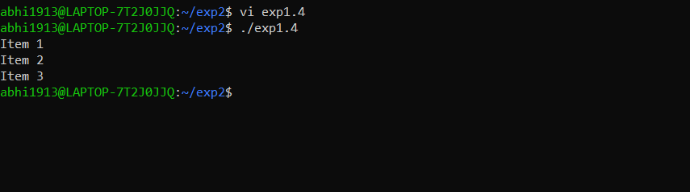

1. **While Loop:-**

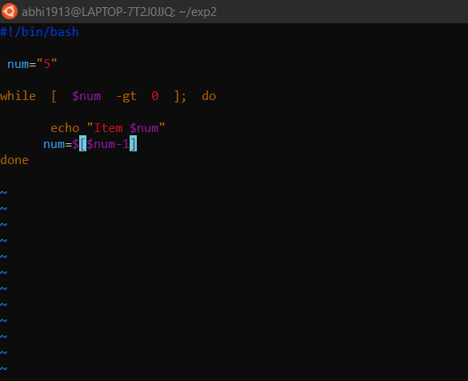

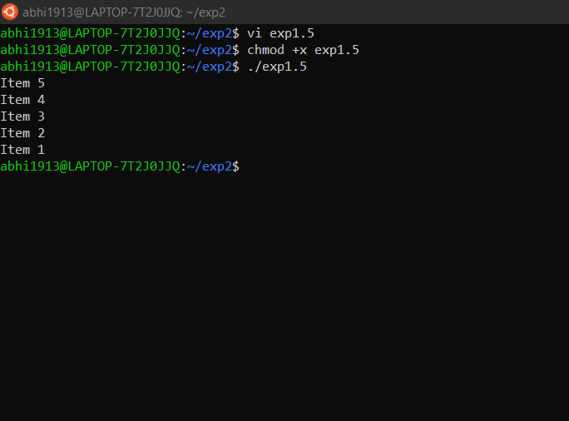

**Experiment-2**

* **Archive logs and move them to a backup directory.**

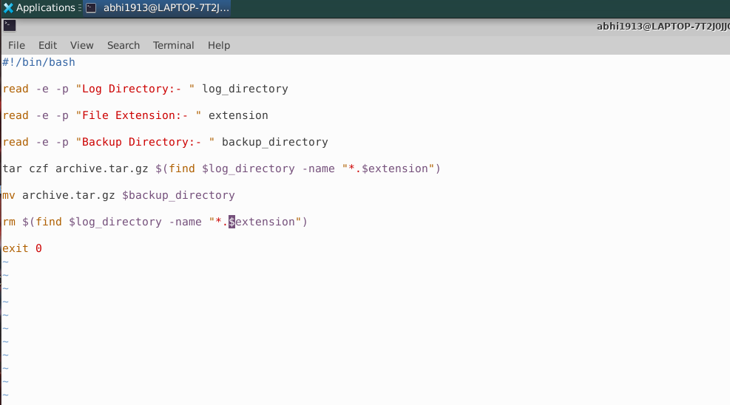

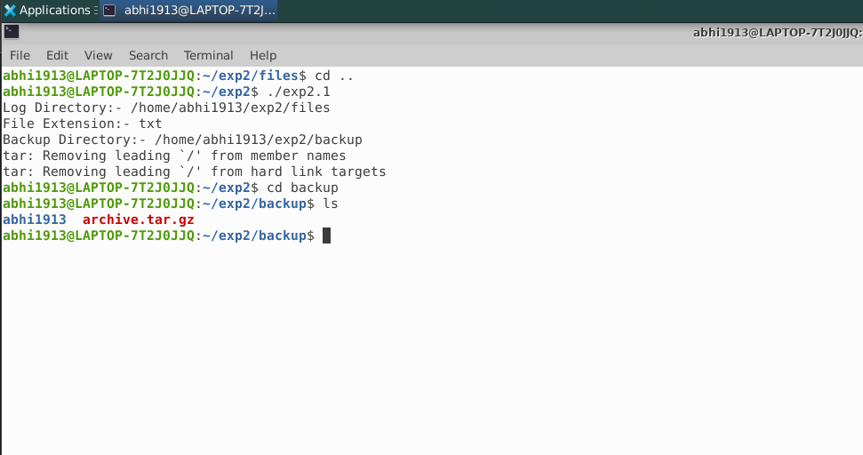

* **Truncate the given file to the specified size.**

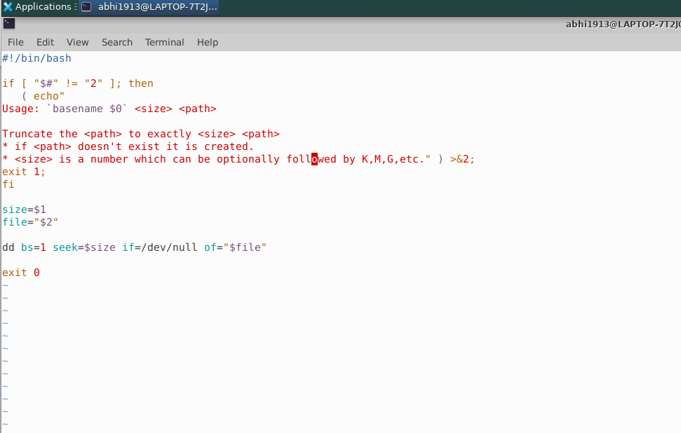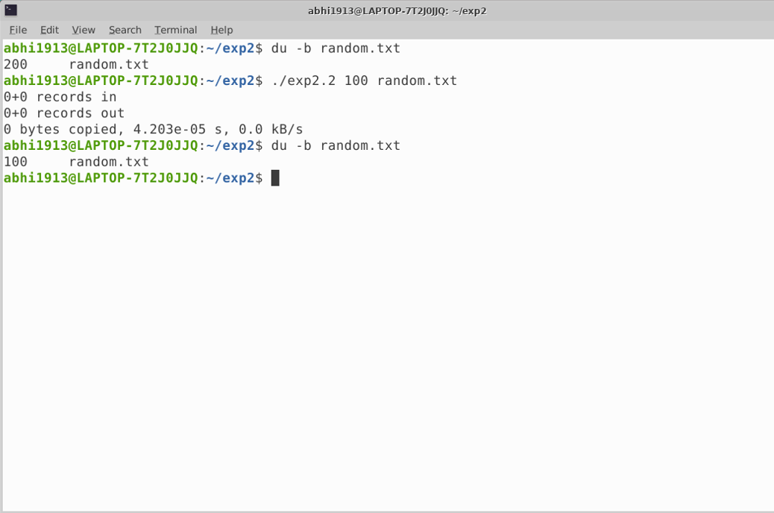

* **Transform the given input text.**

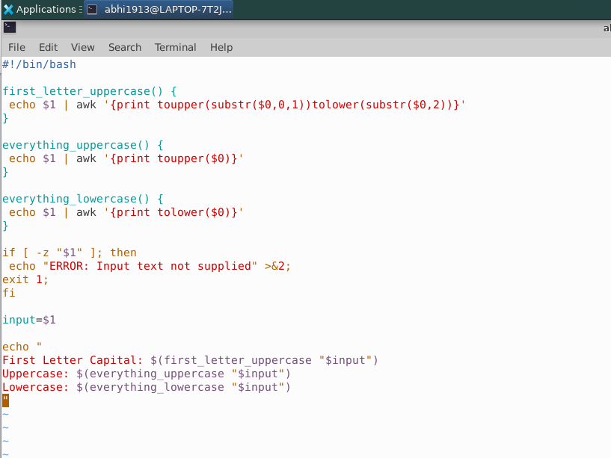

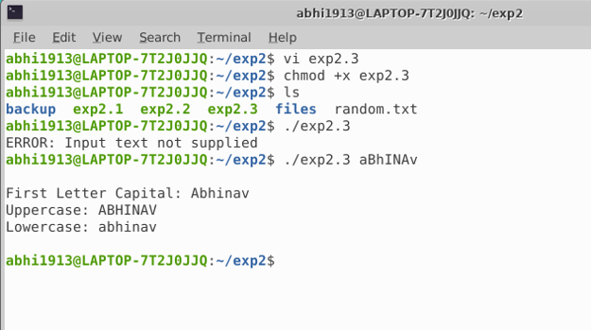

* **Monitor the disk usage and alert if it is beyond the given threshold**

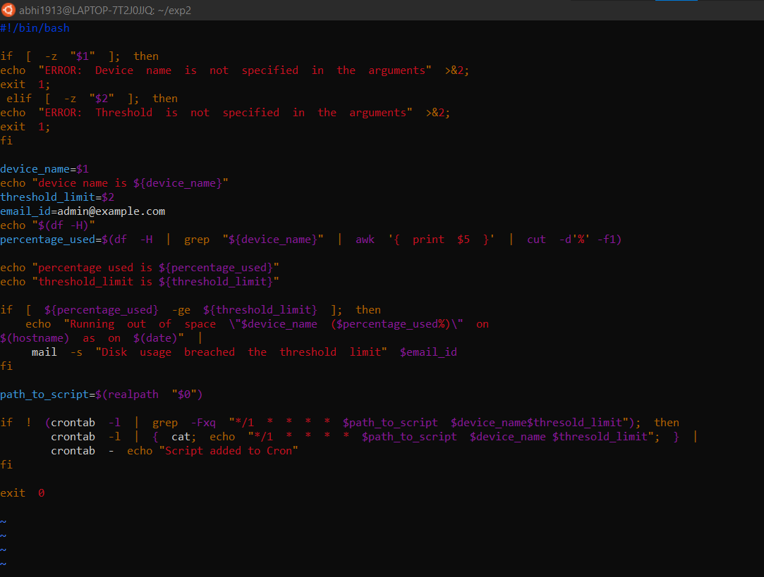

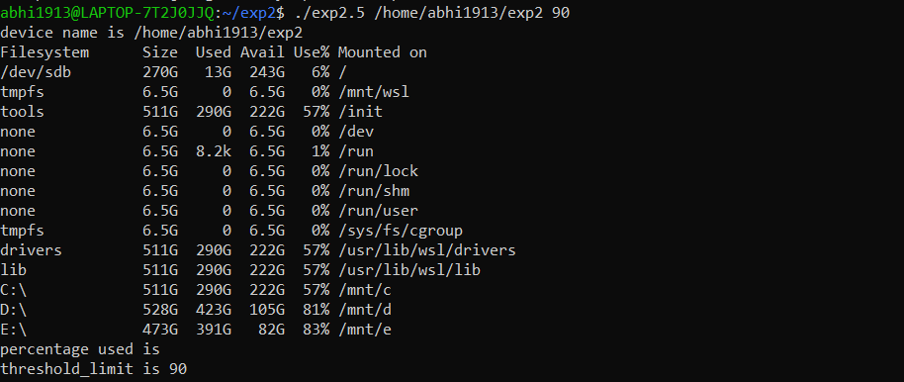

* **Moves the deleted files/folders to the recycle bin**

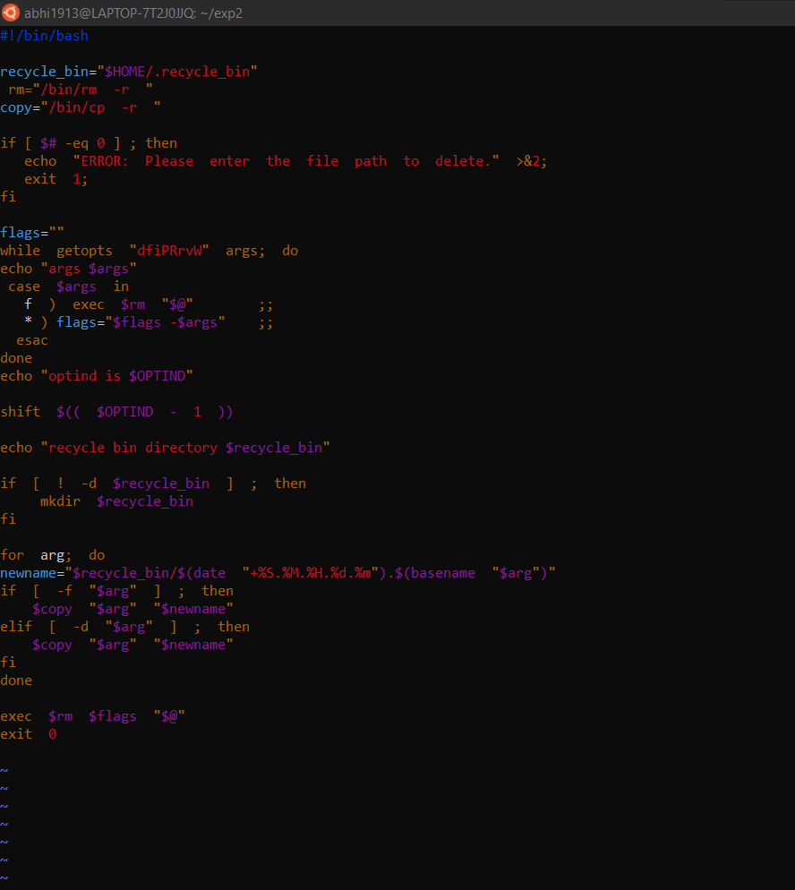

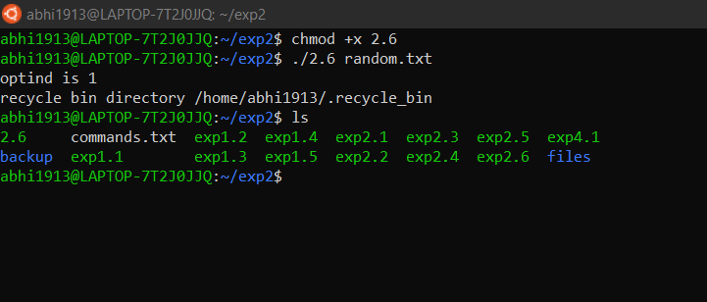

#### Log all the delete operations

#### 

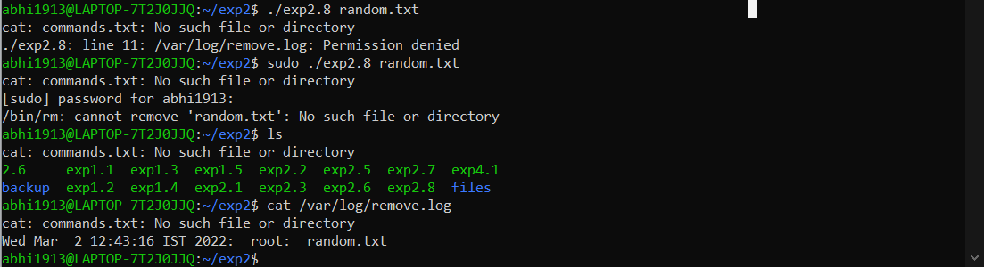

* **Bulk file Downloader:-**

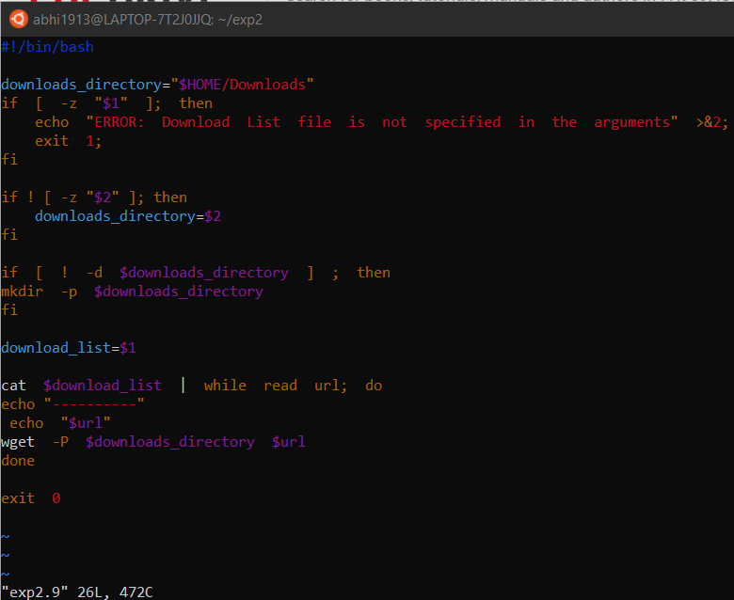

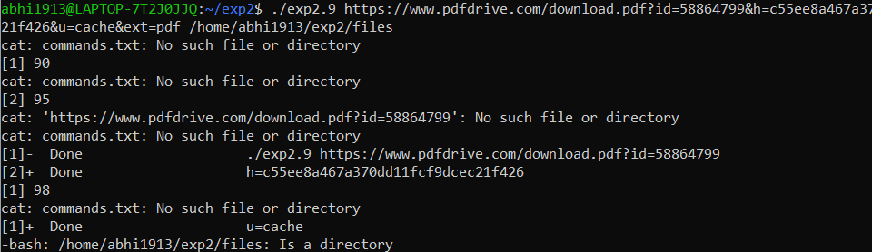

* **To check whether the given input is a valid AlphaNumeric Character:-**

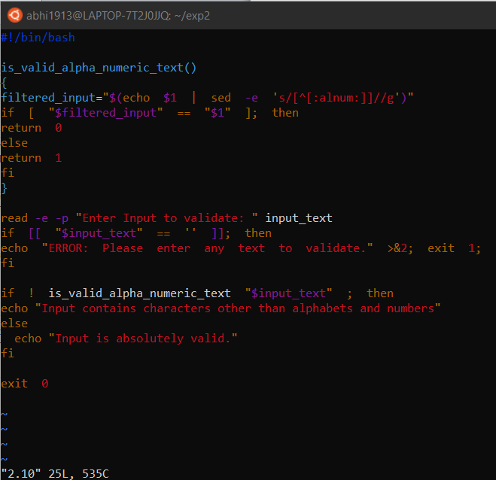

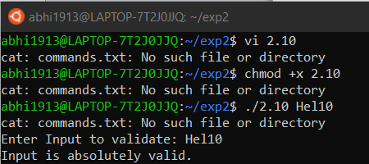

* **Search and Replace a given text with a new text across multiple Files:-**

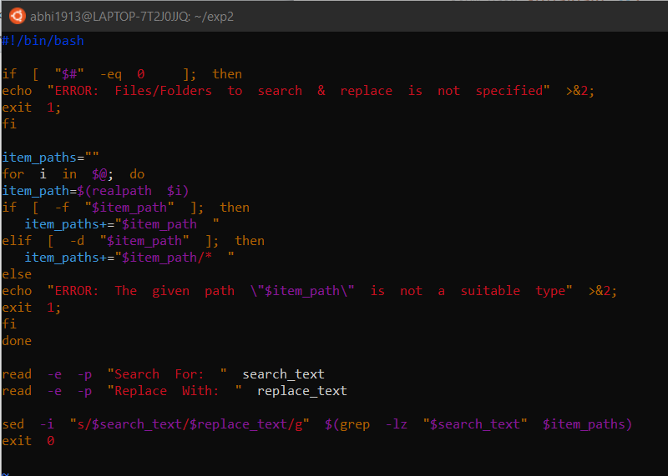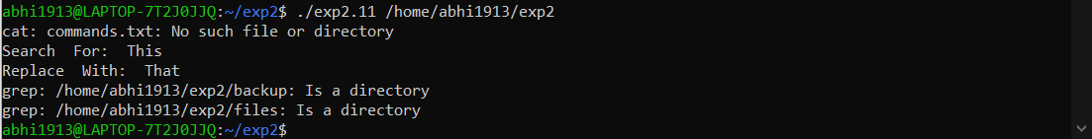

* **Install LAMP stack:-**

**Script:-**

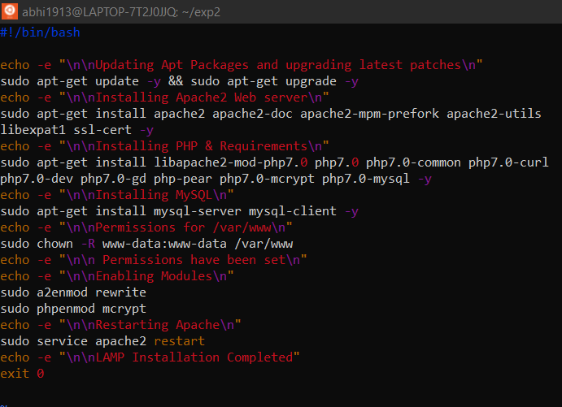

**Execution:-**

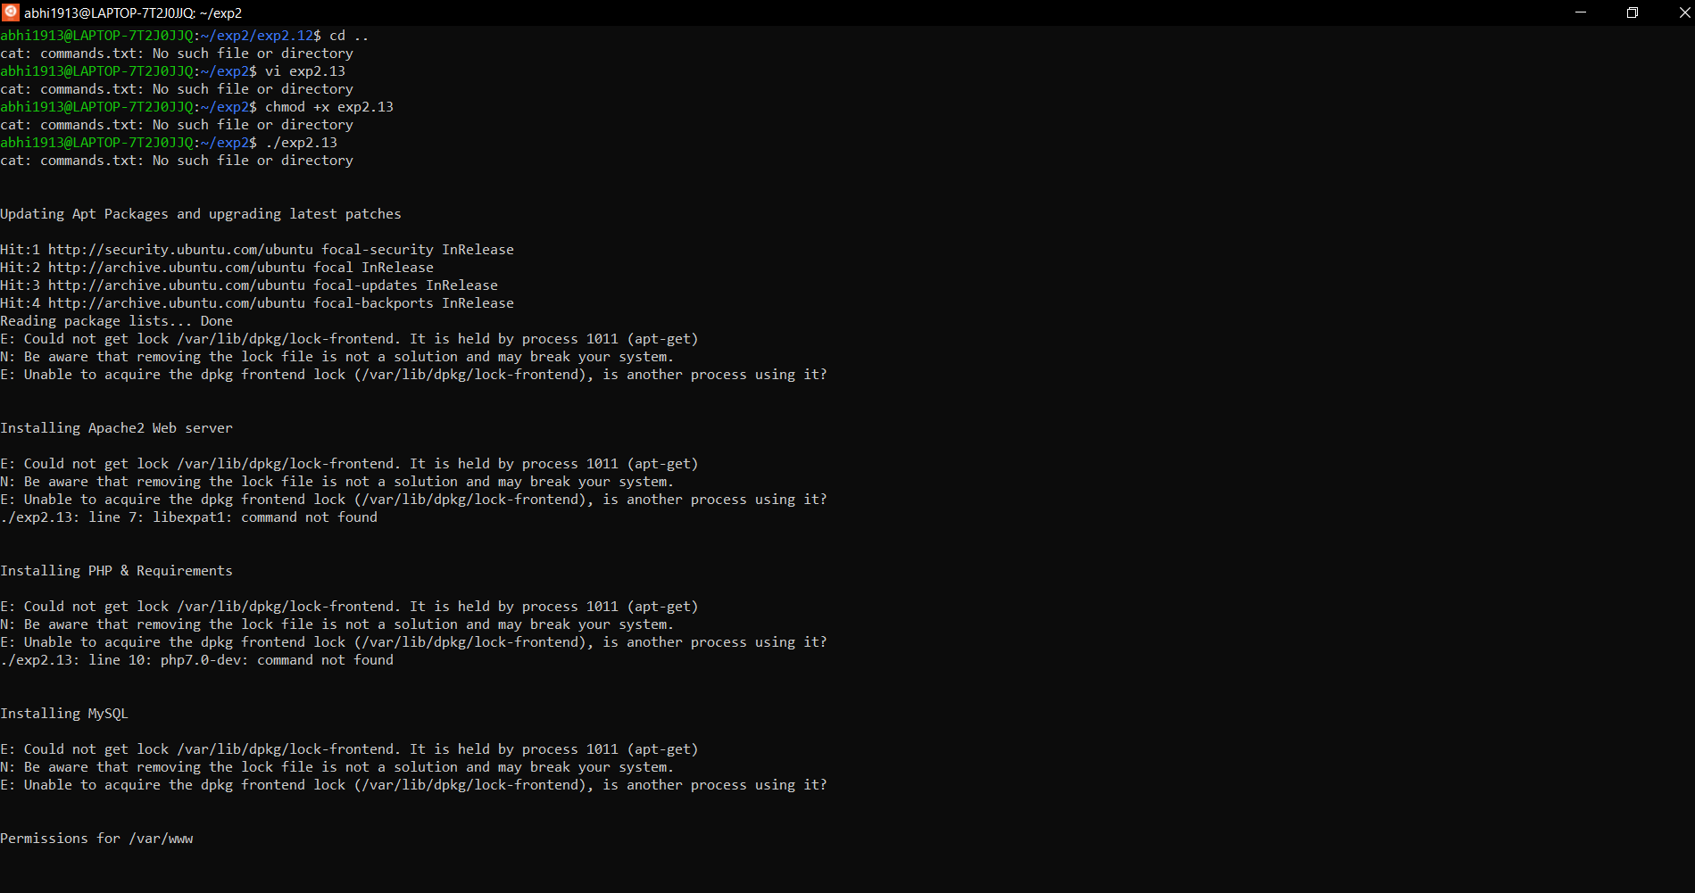

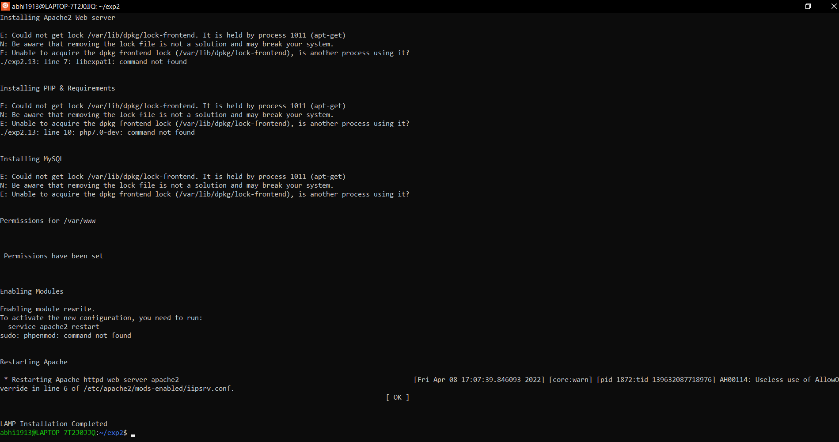

**Experiment-3**

**Crontab to delete archive files 2 days or older**

**Script:-**

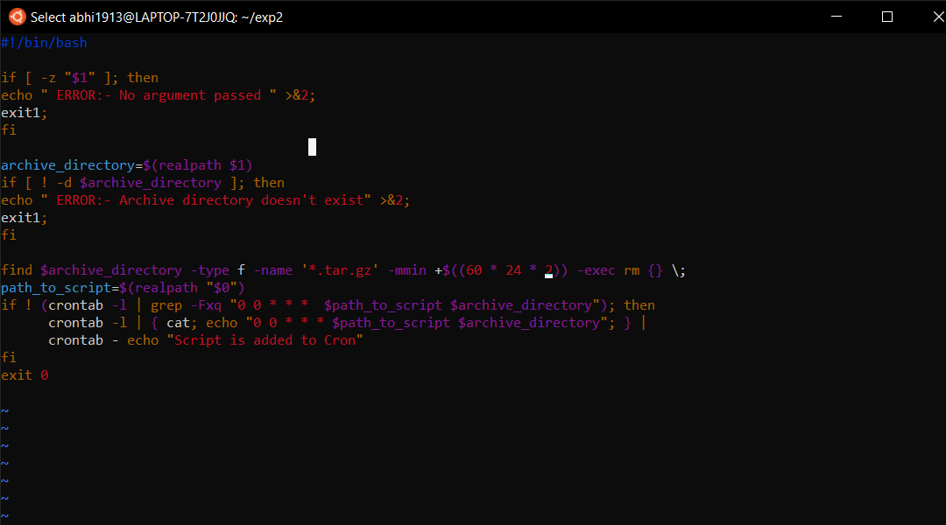

**Execution:-**

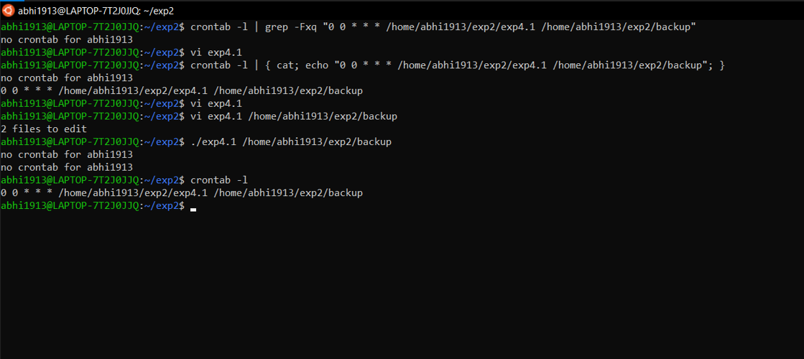

**Experiment-4**

**Working with Make and Makefiles**

* **Basic Setup:-**

**Scripts:-**

**mymath.c:-**

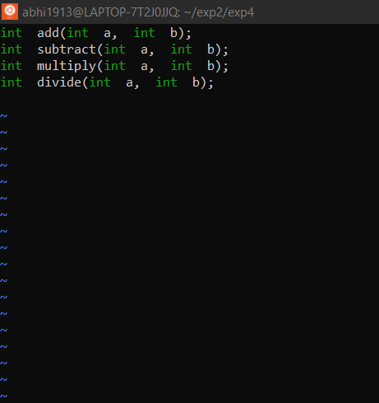

**main.c:-**

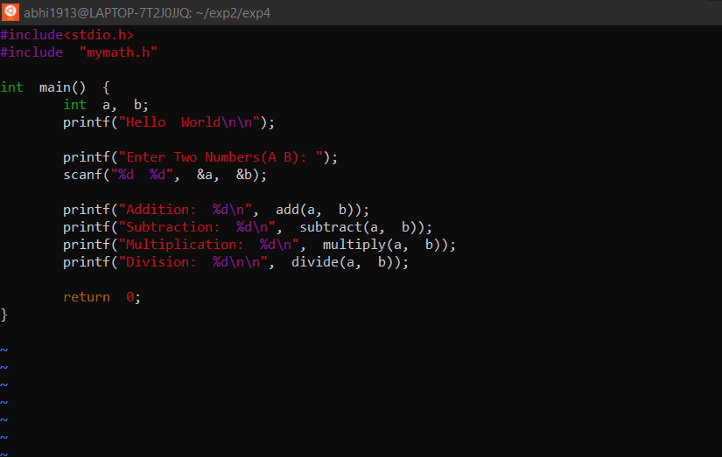

**Execution:-**

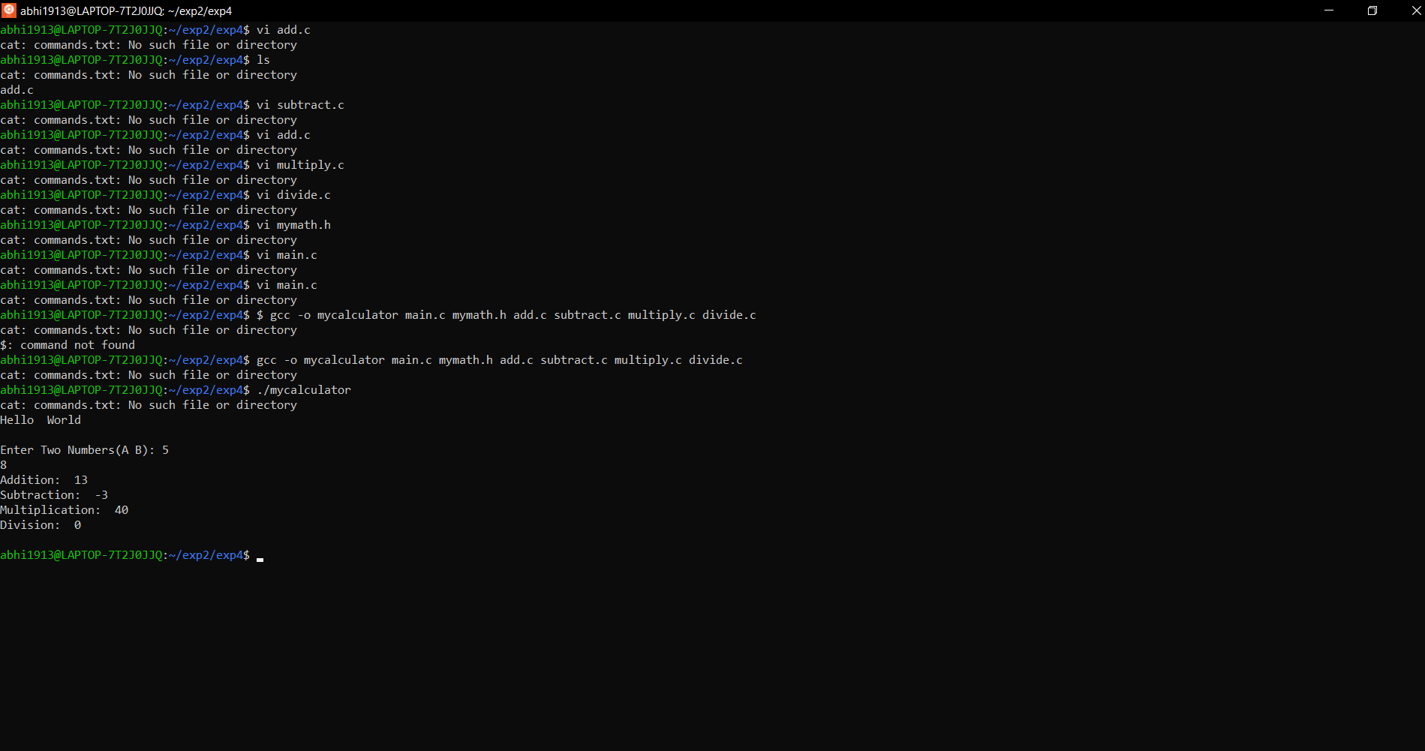

#### Building binary from source code

**Script:-**

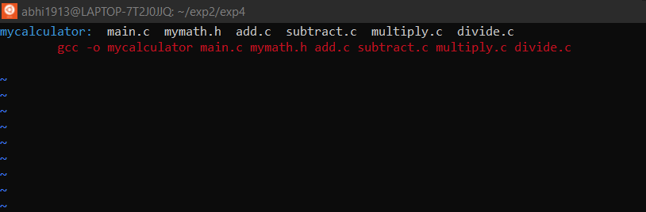

**Execution:-**

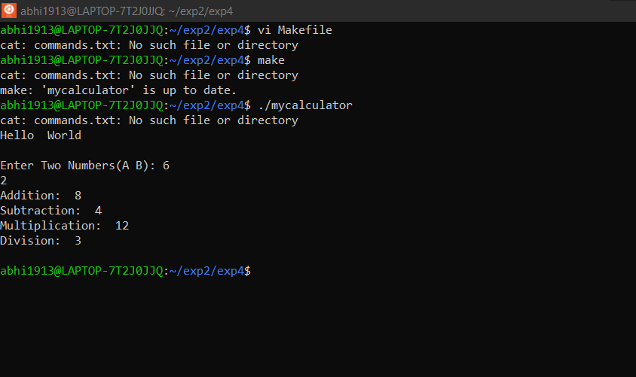

#### Transforming the Makefile to adhere to Best Practices:-

Aim:- To transform the Makefile from the previous lab to implement the best practices.

**Script:-**

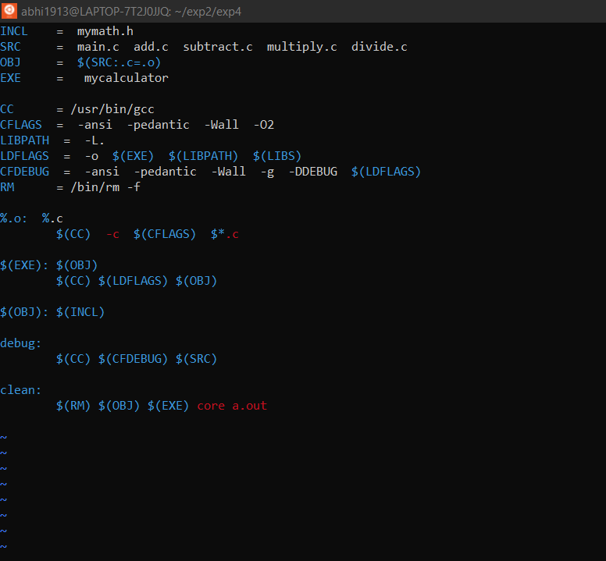

**Execution:-**

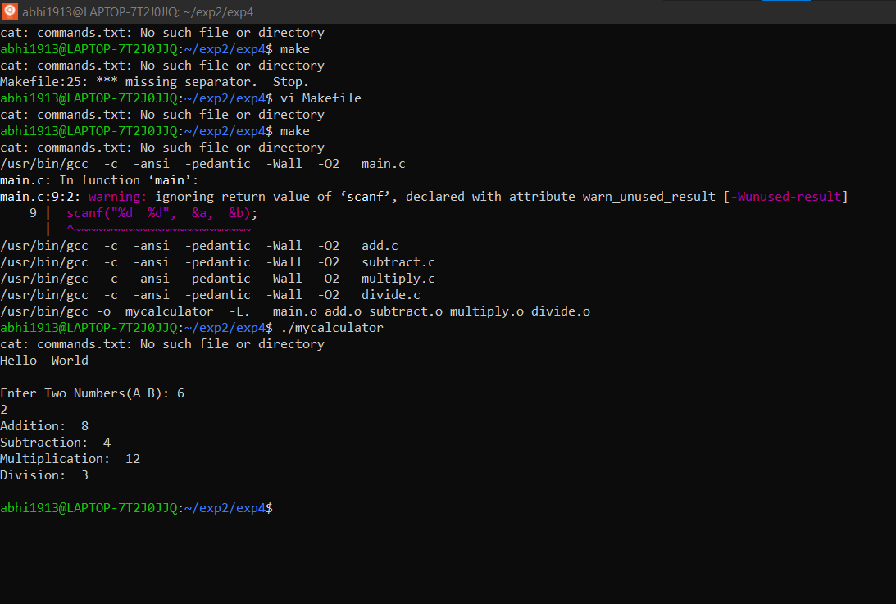

#### Conditionals in Makefile:-

**Aim:-**To use the conditional in Makefile to enable/disable the debug mode based on the value of a macro.

#### Script:-

#### 

#### Execution:-

#### 

#### Experiment-5

#### Error messages for users

#### Redirecting standard streams

1. To redirect the *stdout* to a file:-

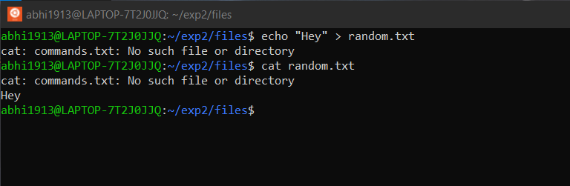

1. To redirect the *stderr* to a file:-

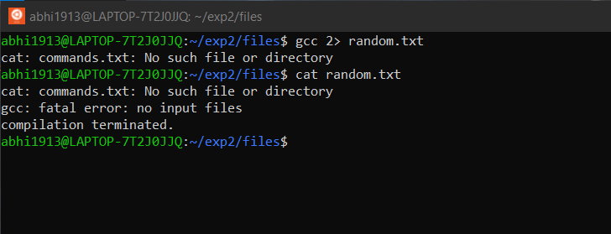

1. To redirect *stderr* to *stdout* and the *stdout* to a file:-

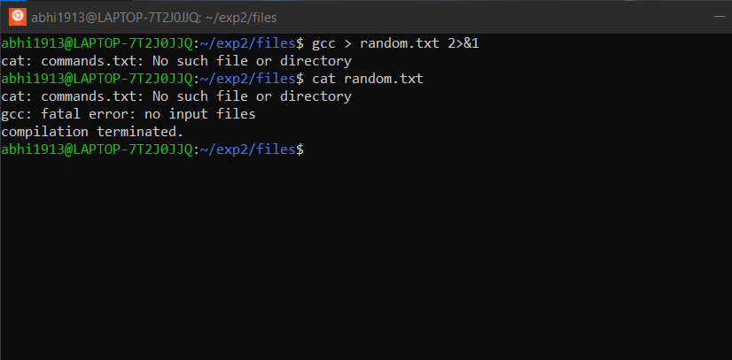

#### Linux exit codes:-

An exit code, also known as a return code, is the code returned to the parent process by an executable program on exit.

* **Method to supress any errors and the error exit code:-**

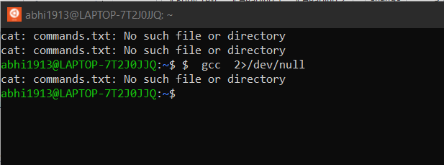

**Experiment-6**

**Creating reusable library scripts for automation scripts**

* **Formatting the Terminal**

Aim:

To write a script that provides a set of functions to format the terminal as listed below:

* + - * + Colourize the given text
        + Show progress bar that fills over a specified time
        + Transform the case of the given text

**Scripts:-**

* format:-

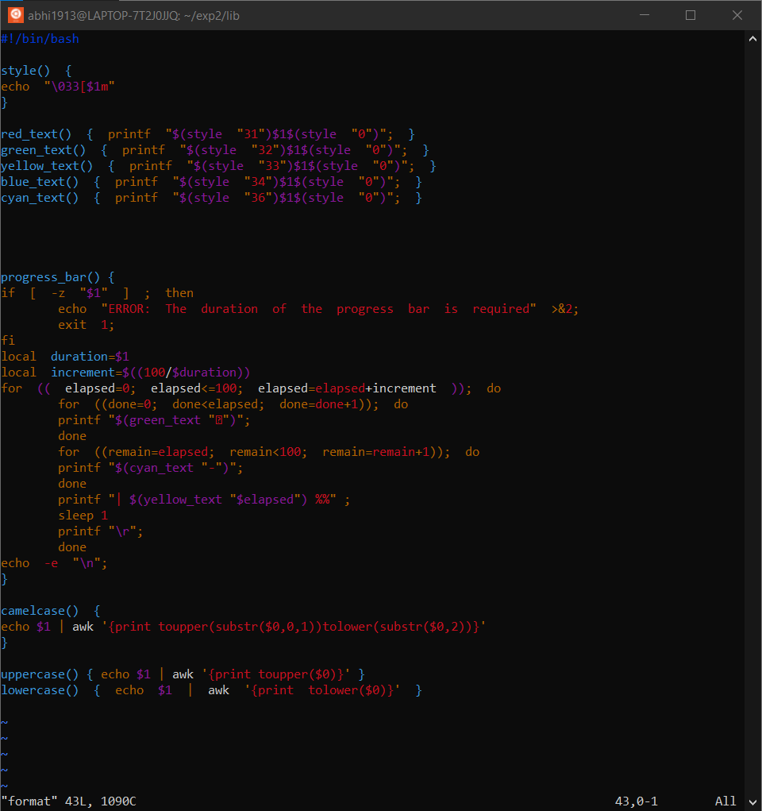

* exp6:-

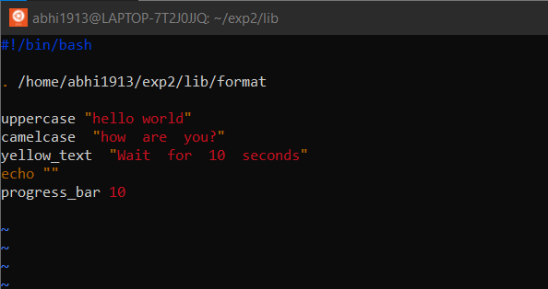

Execution:-

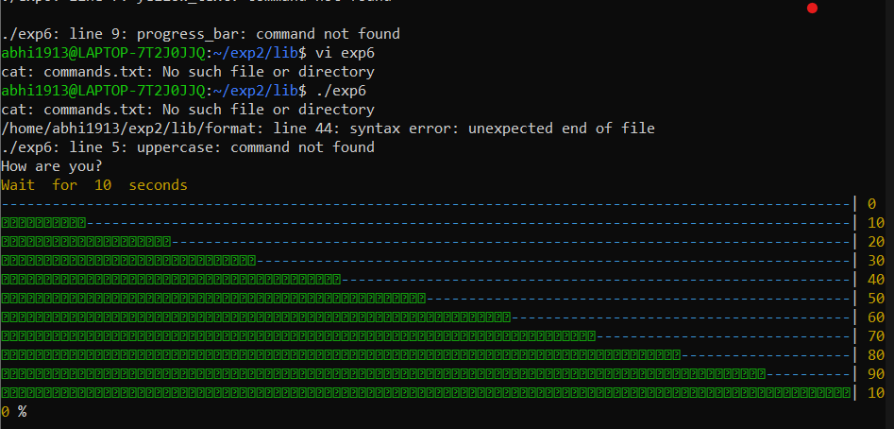

--------------------------------------------------------------------------------------------------------------

#### Experiment-8

#### Adding New Users, Backups and Syslog Files

#### Adding new user and password :-

#### 

#### Syslog in Linux:-

#### 

#### Experiment-9

#### Configuring DNS Server

#### BIND installation:-

#### 

#### 

#### ---------------------------------------------------------------------------

#### Experiment-10

#### Email configuration

**Aim: Sending a test email using standard SMTP commands**

#### Installing mail utils:-

#### 

#### Using SMTP command to send mail:-

#### 

#### Experiment-11

#### Package management

**Aim: manage packages using apt.**

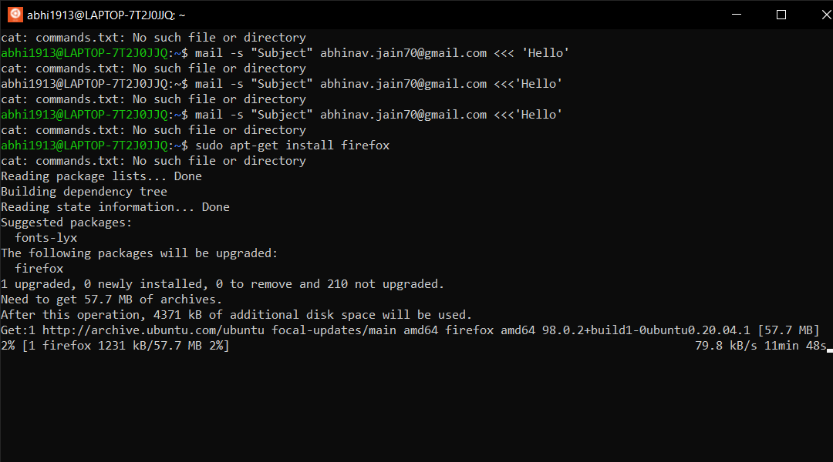

**Experiment-12**

**Network Interface**

* **Configuring login banner message:-**

